ASSIGNMENT NO.9: Data Retrieval, Functions, and Joins in MySQL

Student Name | Aditya Ballal | Roll Number | 20966
Batch | SY. BSc Data Science | Topic | WB(Assignment-9)

Questions:
Q1) Create a MySQL database named CollegeDB and create two tables: OnlineEnrollment and OfflineEnrollment.
OnlineEnrollment Table
Column Name | Data Type | Constraint
StudentID | INT | PRIMARY KEY
StudentName | VARCHAR(50) | NOT NULL
Course | VARCHAR(30)
City | VARCHAR(30)
Marks | INT
OfflineEnrollment Table
Column Name | Data Type | Constraint
StudentID | INT | PRIMARY KEY
StudentName | VARCHAR(50) | NOT NULL
Course | VARCHAR(30)

Column Name | Data Type | Constraint
City | VARCHAR(30)
Marks | INT
Insert at least 6 records into each table. Some records should be common in both tables.
Query:
CREATE DATABASE CollegeDB;
USE CollegeDB;

CREATE TABLE OnlineEnrollment (
StudentID INT PRIMARY KEY,
StudentName VARCHAR(50) NOT NULL,
Course VARCHAR(30),
City VARCHAR(30),
Marks INT
);

CREATE TABLE OfflineEnrollment (
StudentID INT PRIMARY KEY,
StudentName VARCHAR(50) NOT NULL,
Course VARCHAR(30),
City VARCHAR(30),
Marks INT
);

INSERT INTO OnlineEnrollment (StudentID, StudentName, Course, City, Marks) VALUES
(1, 'Rahul Sharma', 'BSc IT', 'Mumbai', 78),
(2, 'Priya Patil', 'BCA', 'Pune', 85),
(3, 'Aman Verma', 'BSc CS', 'Nashik', 67),
(4, 'Sneha Joshi', 'BSc IT', 'Mumbai', 91),
(5, 'Karan Mehta', 'BCA', 'Thane', 74),
(6, 'Neha Shah', 'BSc IT', 'Pune', 88);

INSERT INTO OfflineEnrollment (StudentID, StudentName, Course, City, Marks) VALUES
(4, 'Sneha Joshi', 'BSc IT', 'Mumbai', 91),
(5, 'Karan Mehta', 'BCA', 'Thane', 74),
(7, 'Rohan Desai', 'BSc CS', 'Mumbai', 69),
(8, 'Meera Kulkarni', 'BCA', 'Nashik', 82),
(9, 'Arjun Nair', 'BSc IT', 'Thane', 59),
(10, 'Divya More', 'BCA', 'Mumbai', 93);
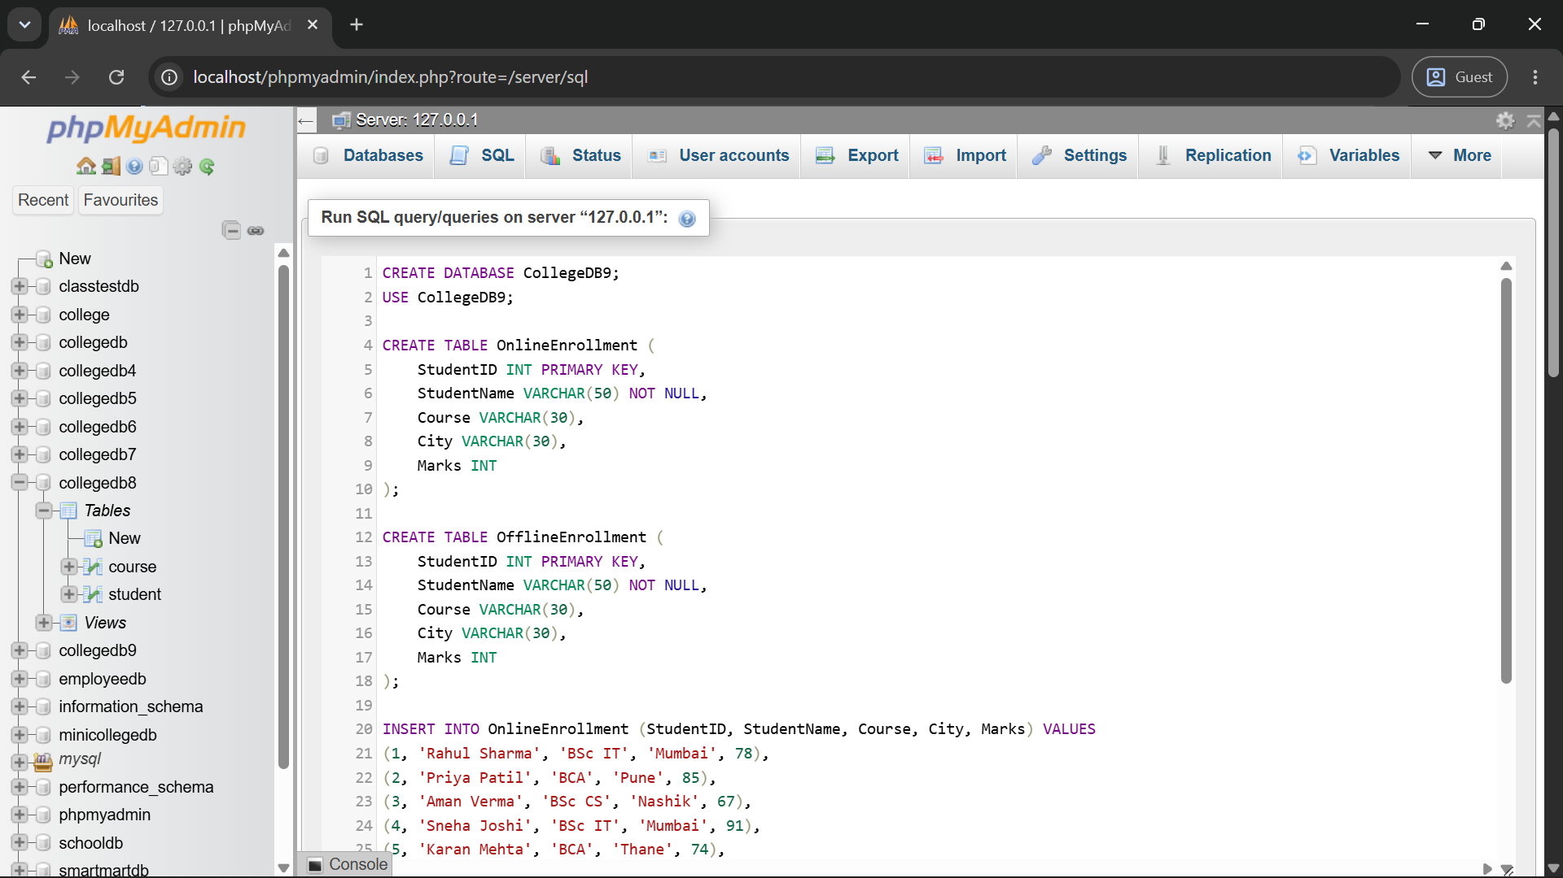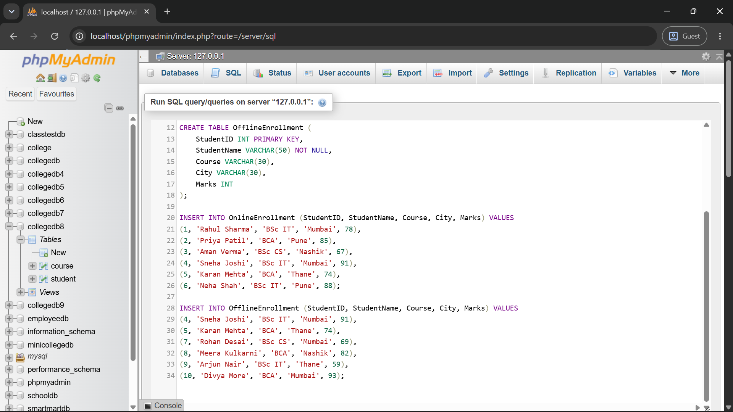
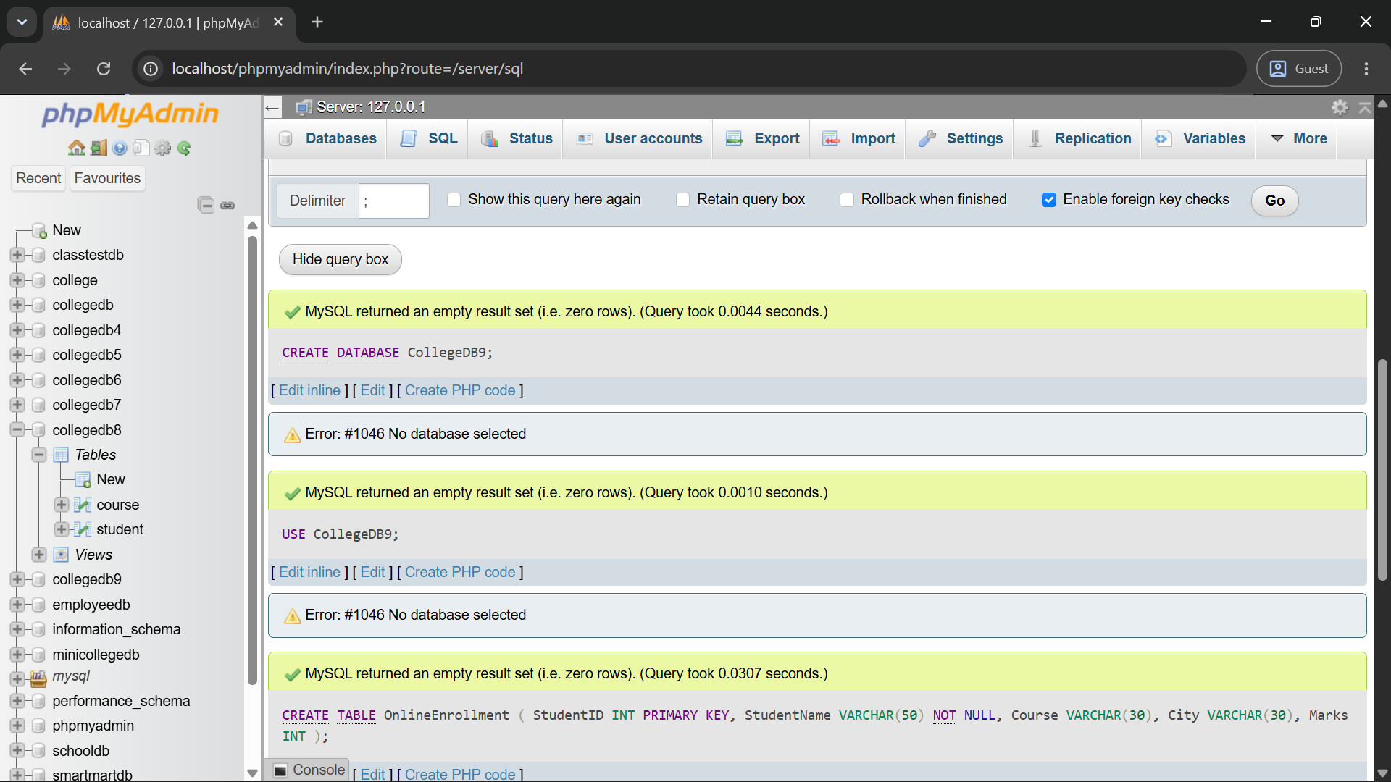
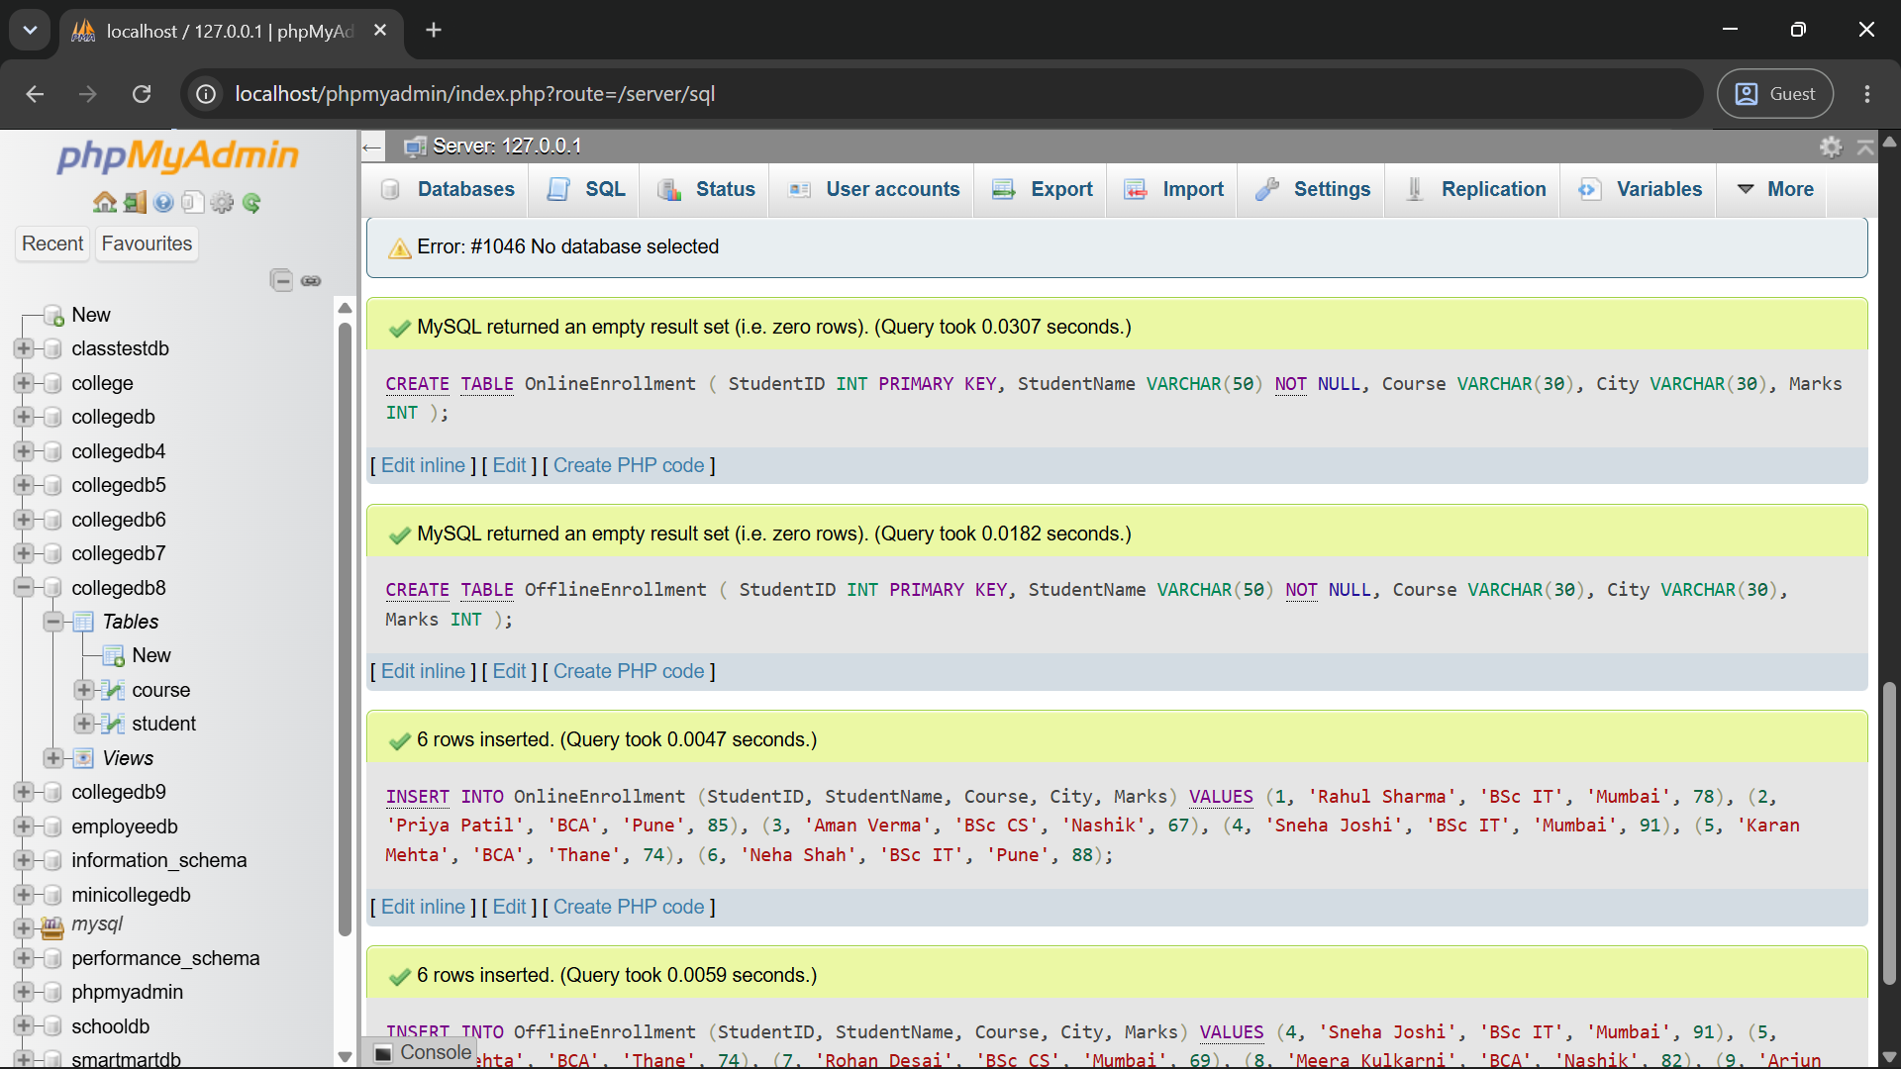
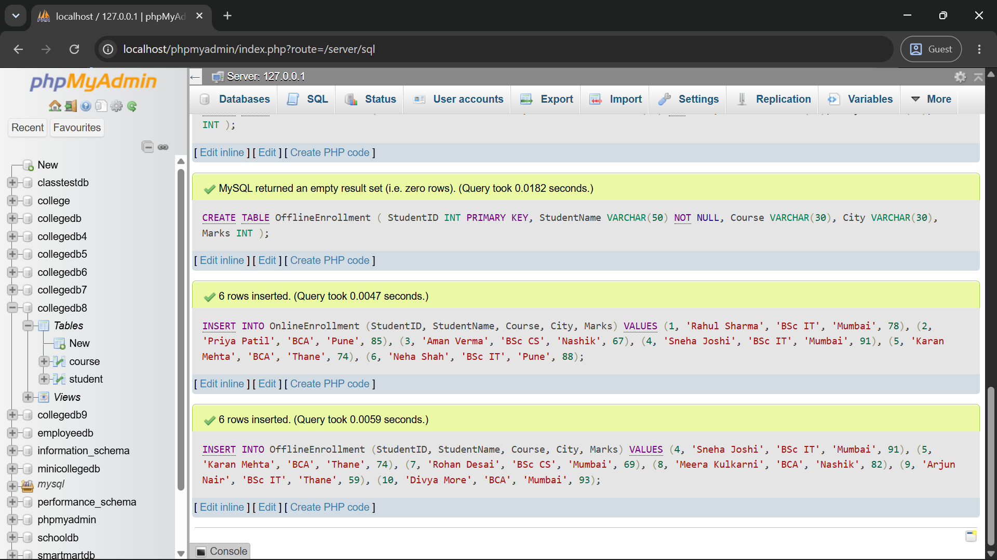

2) Write a MySQL query using UNION to display all unique students from both OnlineEnrollment and OfflineEnrollment.
The output should contain:
Column
StudentID
StudentName
Course
City
Marks
Query:
SELECT StudentID, StudentName, Course, City, Marks FROM OnlineEnrollment
UNION
SELECT StudentID, StudentName, Course, City, Marks FROM OfflineEnrollment;
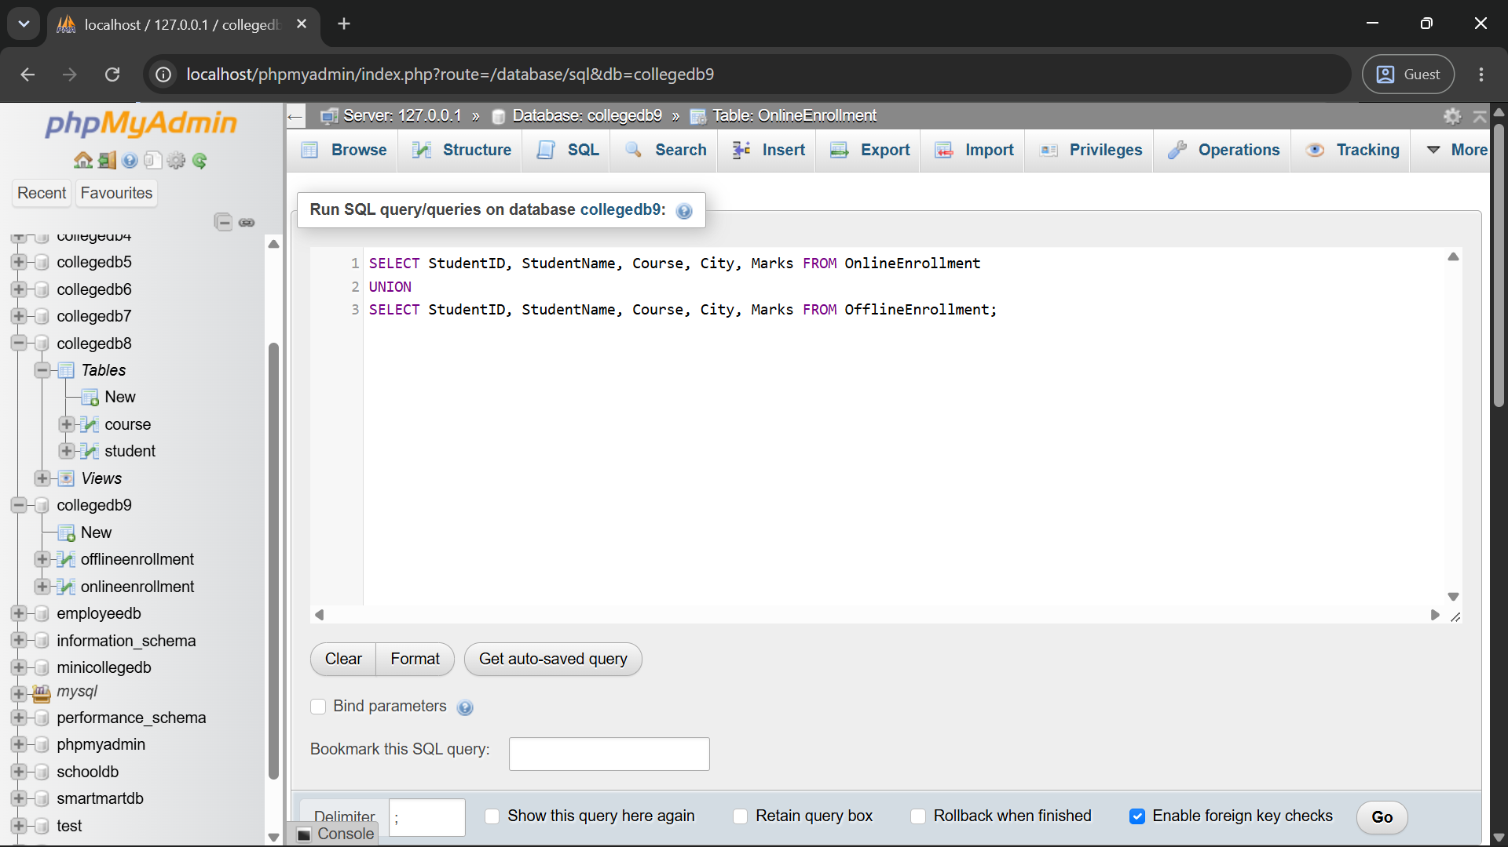
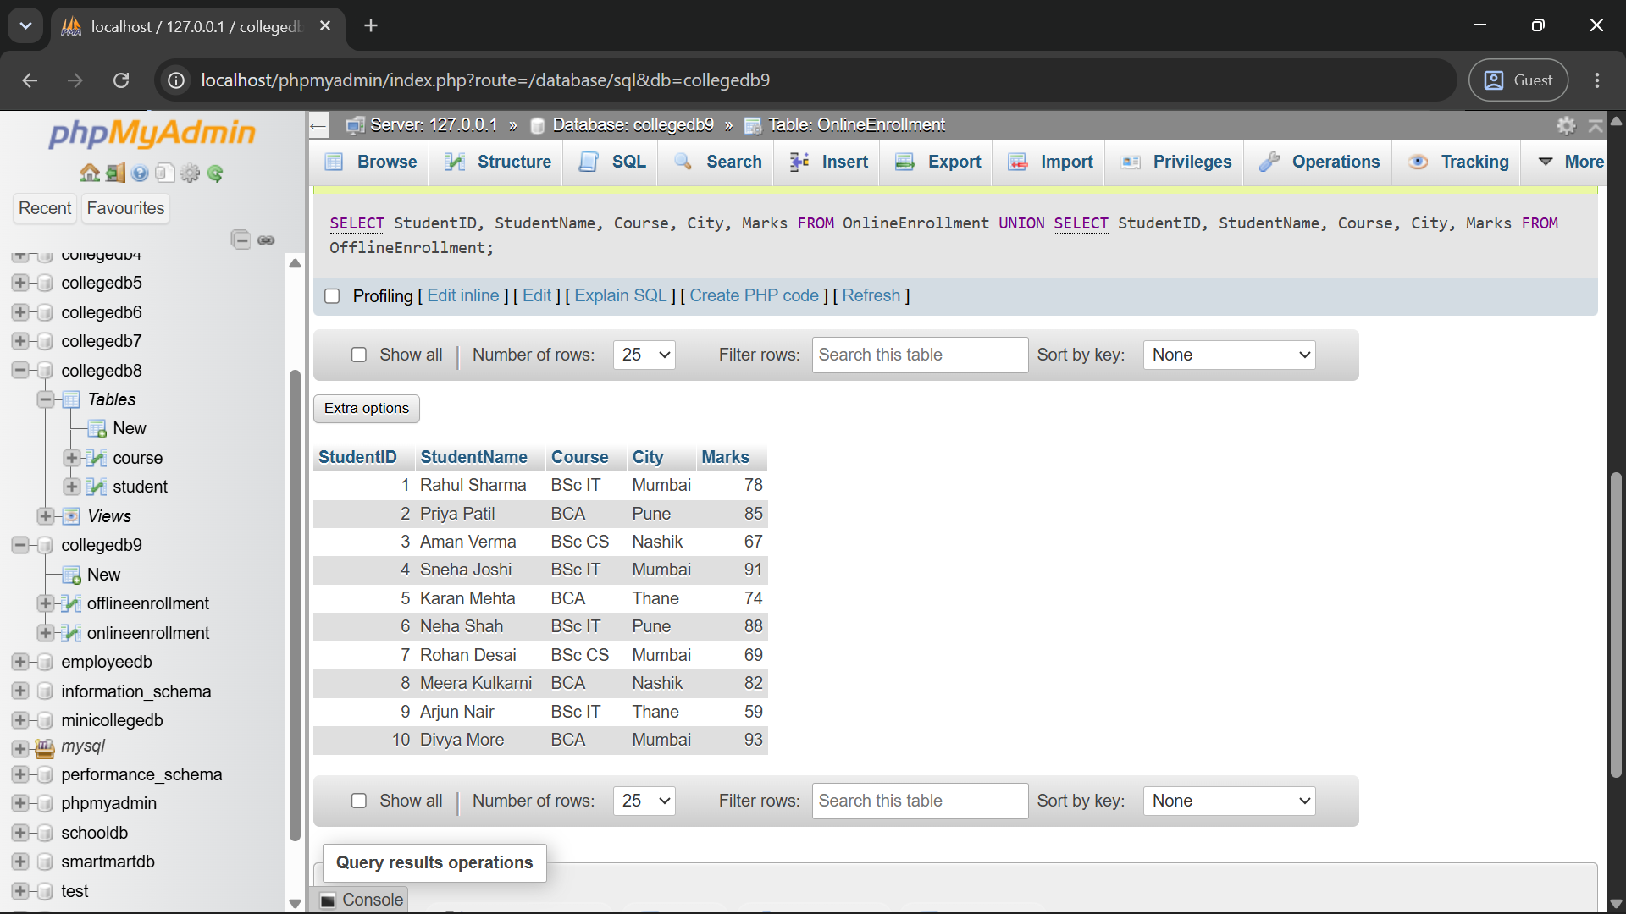
Q3) Write a MySQL query using UNION ALL to combine records from both tables while keeping duplicate records.
Also write one line explaining the difference between UNION and UNION ALL.
Query:
SELECT StudentID, StudentName, Course, City, Marks FROM OnlineEnrollment
UNION ALL
SELECT StudentID, StudentName, Course, City, Marks FROM OfflineEnrollment;
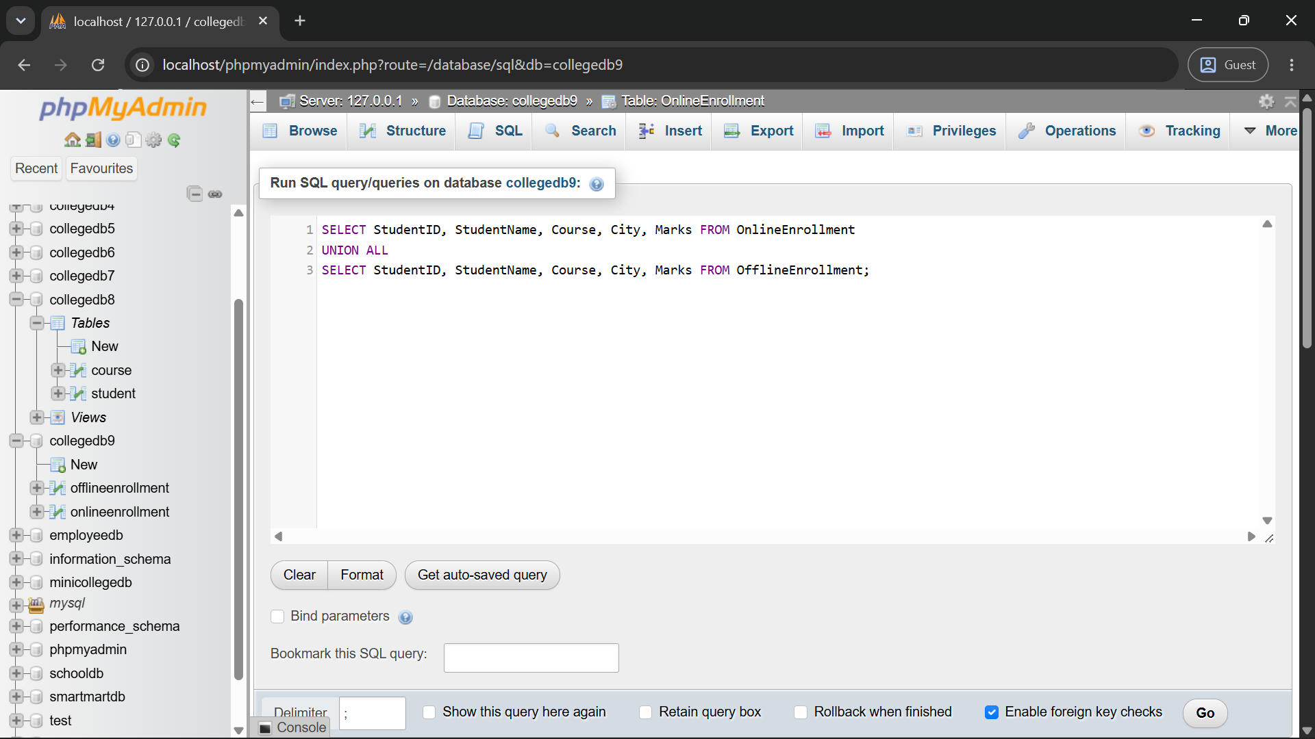
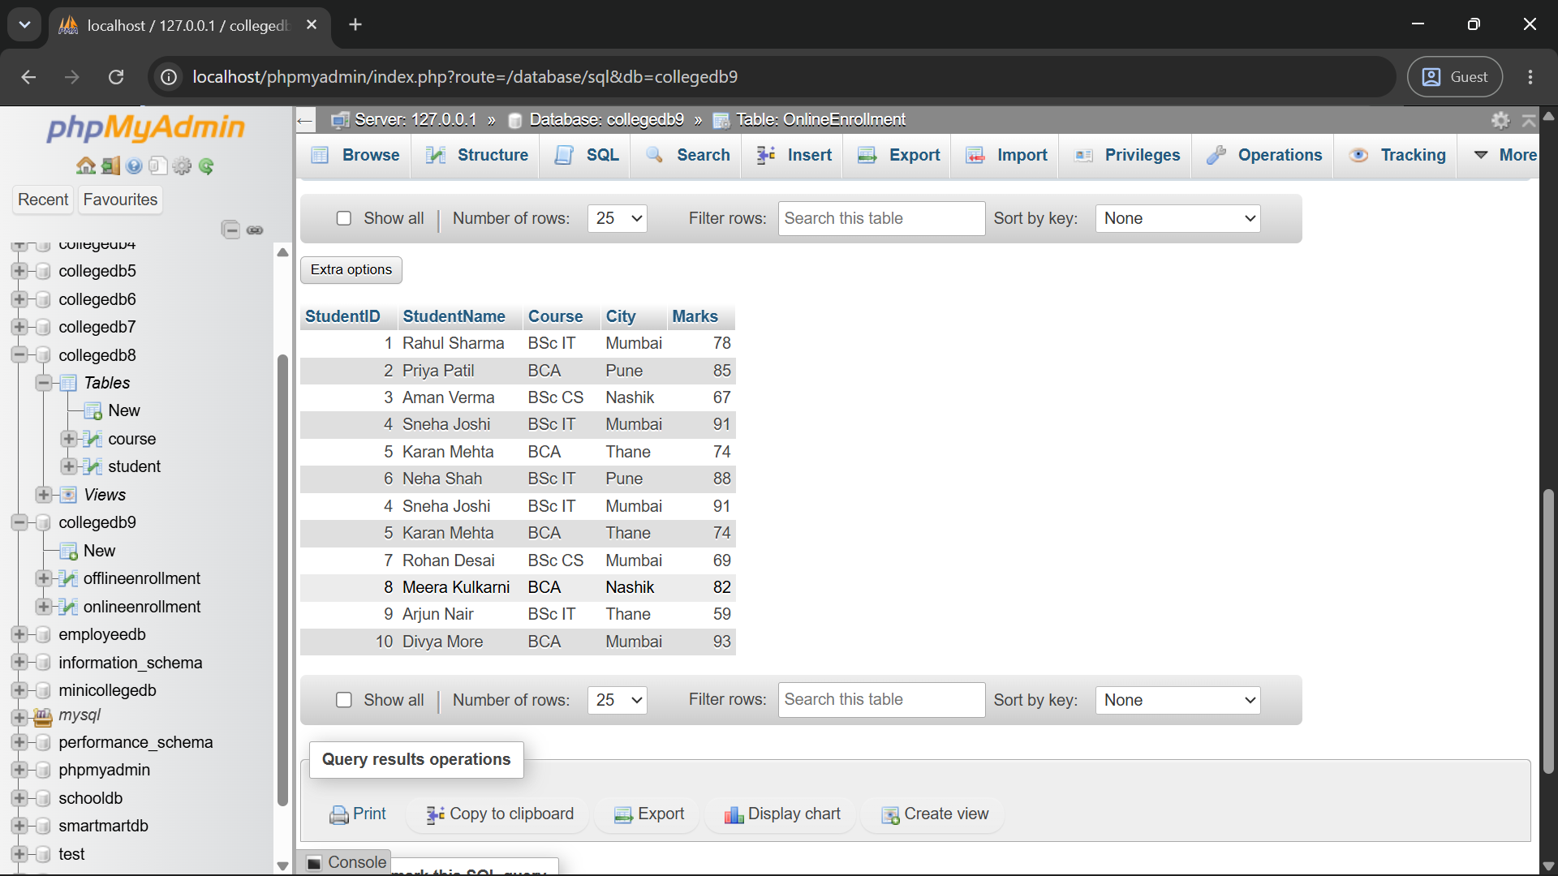
Difference: The UNION operator combines the results of both queries and removes duplicate rows, whereas UNION ALL combines the results but keeps all duplicate rows in the final output
Q4) Write a MySQL query using INTERSECT to display students who are present in both online and offline enrollment tables.
The output should contain:
Column
StudentID
StudentName
Course
City
Marks
Query:
SELECT StudentID, StudentName, Course, City, Marks FROM OnlineEnrollment
INTERSECT
SELECT StudentID, StudentName, Course, City, Marks FROM OfflineEnrollment;
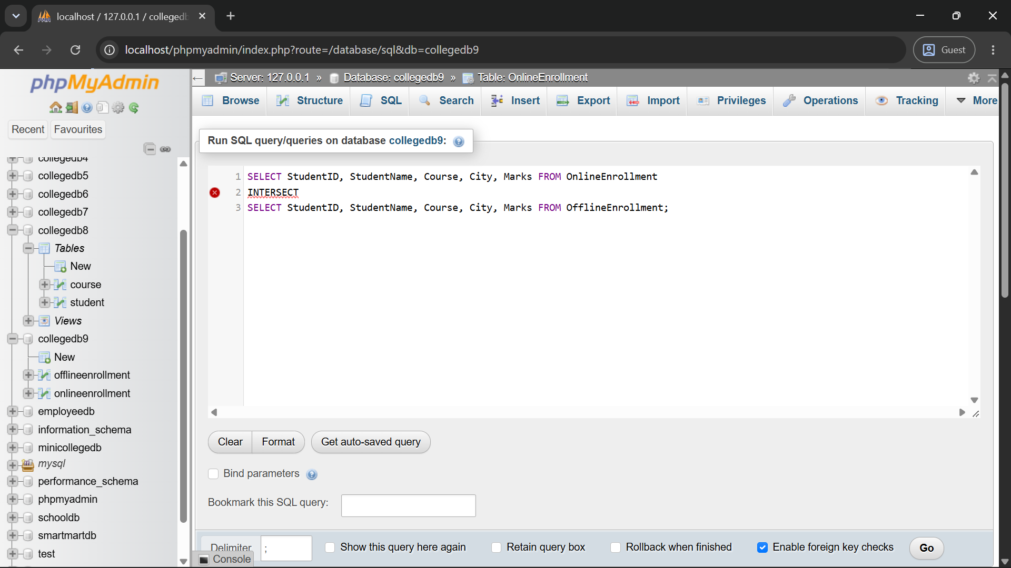
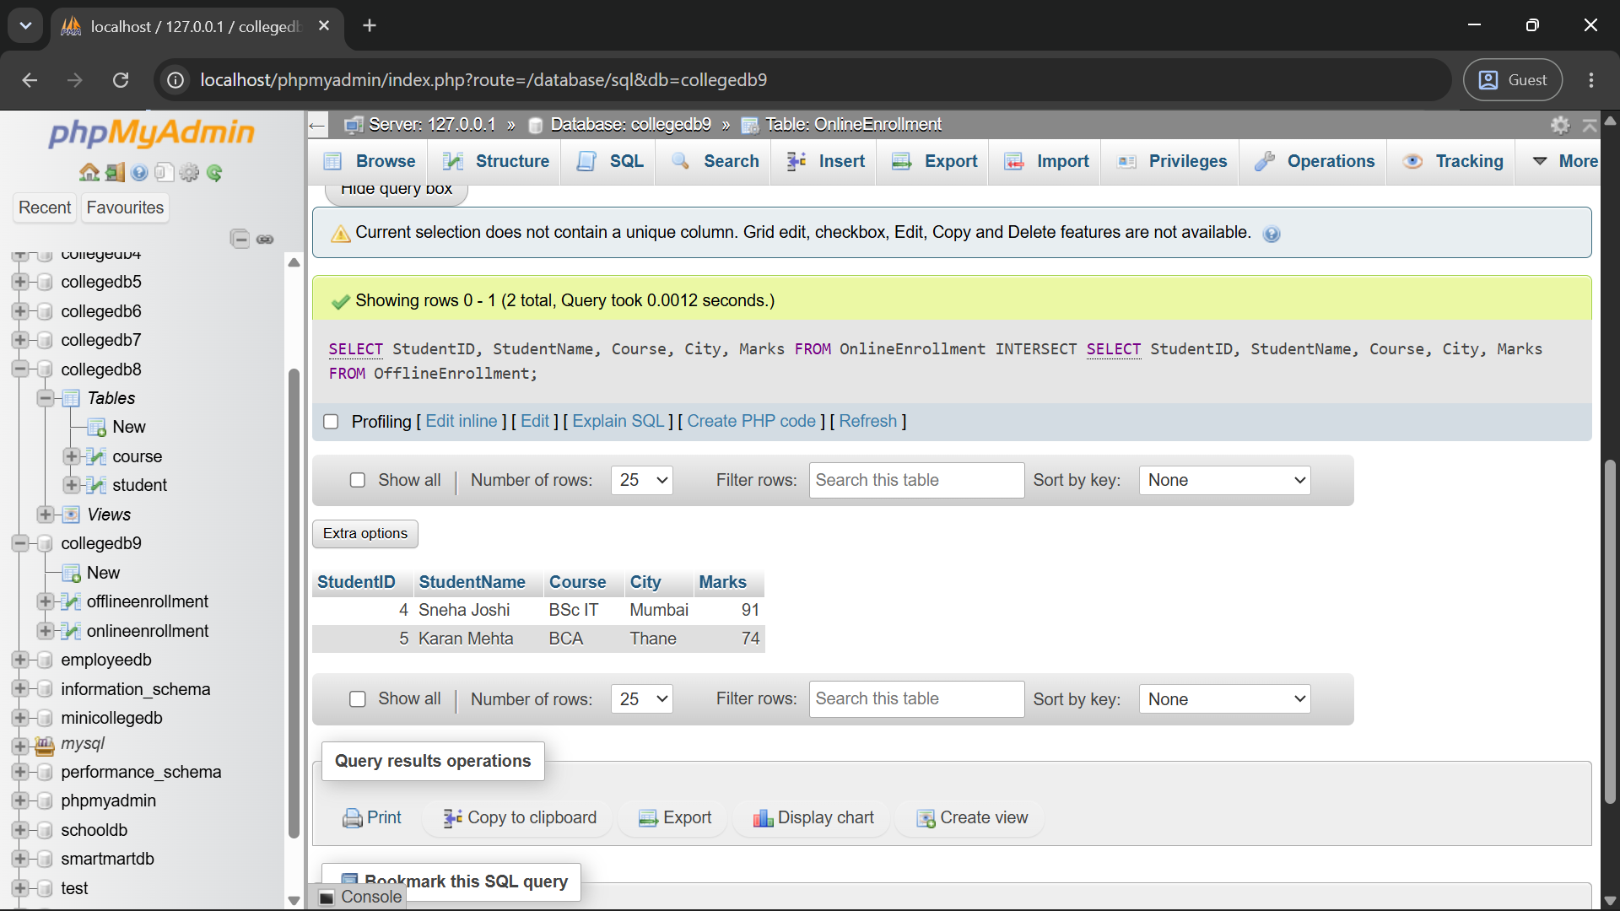
Q5) Write a MySQL query using EXCEPT to display students who are present only in the online enrollment table.
The output should contain:
Column
StudentID
StudentName
Course
City
Marks
Query:
SELECT StudentID, StudentName, Course, City, Marks FROM OnlineEnrollment
EXCEPT
SELECT StudentID, StudentName, Course, City, Marks FROM OfflineEnrollment; 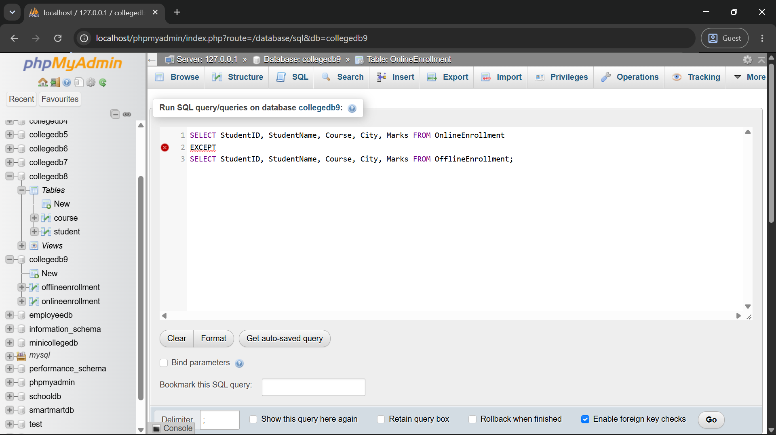
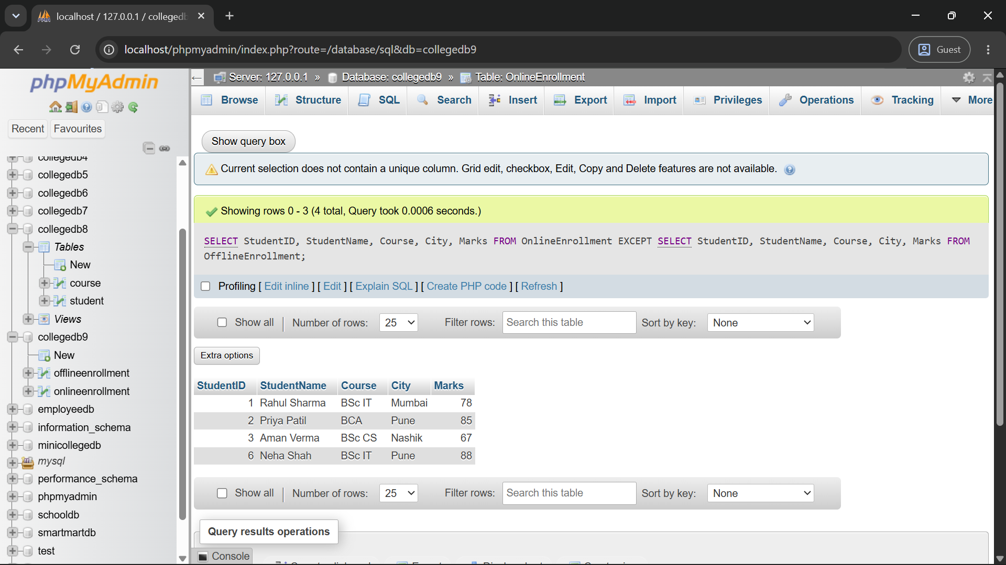

Q6) Write a MySQL query to display high-scoring students from both tables.
The query should:

Requirement
Select students with marks greater than or equal to 85
Use UNION to combine both tables
Display StudentID, StudentName, Course, and Marks
Sort the final output by Marks in descending order
Query:
SELECT StudentID, StudentName, Course, Marks FROM OnlineEnrollment
WHERE Marks >= 85
UNION
SELECT StudentID, StudentName, Course, Marks FROM OfflineEnrollment
WHERE Marks >= 85
ORDER BY Marks DESC;
